PCCCS495 – Term II Project Report

E-Commerce Shopping Cart
Management System

Submitted By
Student Name: Soumyajit Ghosh
Roll : 77
Stream : CSE (IoT)
Enrollment No. : 12024052019069
Institution: Institute of Engineering and Management
GitHub Repository: https://github.com/IEM-Gurukul/term-ii-project-submission-Soumya01A

Table of Contents
1. | Introduction
2. | Problem Statement
3. | Objectives
4. | Target Users
5. | System Architecture & Design Justification
5.1 | Proposed Architecture
5.2 | System Features
6. | UML Class Diagram
7. | Core Features
8. | OOP Concepts – Explained with Code
8.1 | Abstraction
8.2 | Encapsulation
8.3 | Polymorphism
8.4 | Exception Handling
8.5 | Collections (ArrayList)
9. | Results / Output
10. | Conclusion

1. Introduction
With the rapid growth of online shopping, managing products efficiently in a shopping cart is an essential feature of any e-commerce system. A shopping cart allows users to select, modify, and review items before purchase. This project focuses on developing a simple shopping cart management system using Java and object-oriented programming (OOP) concepts..
2. Problem Statement
Many existing e-commerce systems handle cart management inefficiently. Common problems include:
- No validation when users enter invalid quantities or product IDs.
- Items being duplicated instead of quantity being incremented on repeated additions.
- No graceful error handling — system crashes on bad input.
- Tightly coupled code with no separation of concerns, making maintenance difficult.

This system addresses each pain point through well-structured OOP design, input validation, and exception handling — creating a reliable, extensible cart management solution.
3. Objectives
- To design a simple shopping cart system
- To implement OOP concepts in a real-world application
- To allow users to add, update, and remove items
- To calculate total cost accurately
- To improve code structure and maintainability.

4. Target Users
- Online shoppers who need to manage cart items — adding products, adjusting quantities, and viewing totals before purchase.
- Java / OOP students and developers who want a clean reference implementation using core OOP principles.

5. System Architecture & Design Justification
5.1 Proposed Architecture
The system is divided into six classes, each with a single, well-defined responsibility (Single Responsibility Principle):
Class | Responsibility | Pattern / Role
Product | Stores product data (ID, name, price) | Entity / Model
CartItem | Links a Product with its quantity | Value Object
Cart | Manages all cart operations | Service / Manager
User | Represents the customer | Entity / Actor
Shop | Holds product catalogue & search | Repository / Catalogue
OnlineShoppingApp | Entry point, menu, user interaction | Controller / Main

5.2 System Features
The system consists of the following components:

- Product Class: Stores product details (ID, name, price)
- ShoppingCart Class: Handles cart operations
- OrderManager Class: Calculates total cost
- Main Class: Controls program execution.

6. UML Class Diagram
The diagram below represents the class structure, fields, methods, and relationships of the system. Relationships include association (has-a), composition (contains), and dependency (uses).
UML Class Diagram
+-----------+ +------------------+ +--------------+
| Product | --> | ShoppingCart | --> | OrderManager |
+-----------+ +------------------+ +--------------+
| id | | productList | | processOrder |
| name | +------------------+ +--------------+
| price | | addItem() |
+-----------+ | removeItem() |
| display() | | updateItem() |
+-----------+ | calculateTotal() |
+------------------+
Figure 1: UML Class Diagram – E-Commerce Shopping Cart Management System
7. Core Features
- 1. Add Items to Cart: Users search the Shop catalogue by name or ID and add a chosen quantity. If the item already exists, the quantity is incremented — no duplicates.
- 2. Update Item Quantity: Users can change the quantity of any cart item by product ID. Entering 0 triggers automatic removal, handled via exception logic.
- 3. Remove Items from Cart: Any item is removed individually by product ID. A meaningful error message is shown if the item is not present.
- 4. Display Cart Contents: A formatted table shows: product ID, name, unit price, quantity, and subtotal for each item, followed by a grand total line.
- 5. Calculate Total Price: The cart dynamically computes the grand total by iterating CartItem objects and summing (price × quantity) after every operation.

8. OOP Concepts – Explained with Code
8.1 Abstraction
- Use classes like Product and ShoppingCart
- Hide internal implementation.
Java
class Product {
int id;
String name;
double price;

void display() {
System.out.println(name + " - " + price);
}
}
8.2 Encapsulation
What it means: Encapsulation bundles data and methods together and restricts direct access using access modifiers.
How it is applied: All fields in Product and CartItem are private. External classes can only read or modify values through controlled getters and validated setters.
Java
class Electronics extends Product {
int warranty;
}
8.3 Polymorphism
What it means: The same method name behaves differently depending on the object or context (overriding and overloading).
How it is applied: toString() is overridden in both Product and CartItem to produce context-specific output. addItem() is overloaded to accept an optional quantity.
Java
void display() {
System.out.println("Product details");
}

void display(String name) {
System.out.println("Product: " + name);
}
8.4 Exception Handling
What it means: Exception handling detects, reports, and recovers from runtime errors gracefully — preventing crashes and giving users meaningful feedback.
How it is applied: Custom and built-in exceptions are used for invalid quantities, non-existent product IDs, null products, and bad user input.
Java
try {
int qty = Integer.parseInt(input);
} catch (NumberFormatException e) {
System.out.println("Invalid input!");
}
8.5 Collections (ArrayList)
What it means: Java Collections provide powerful, resizable data structures with rich API methods for searching, filtering, and iteration.
How it is applied: Cart uses ArrayList<CartItem> for internal storage, leveraging removeIf, streams, and enhanced for-loops for concise, expressive code.
Java
ArrayList<Product> cart = new ArrayList<>();
9. Results/Output
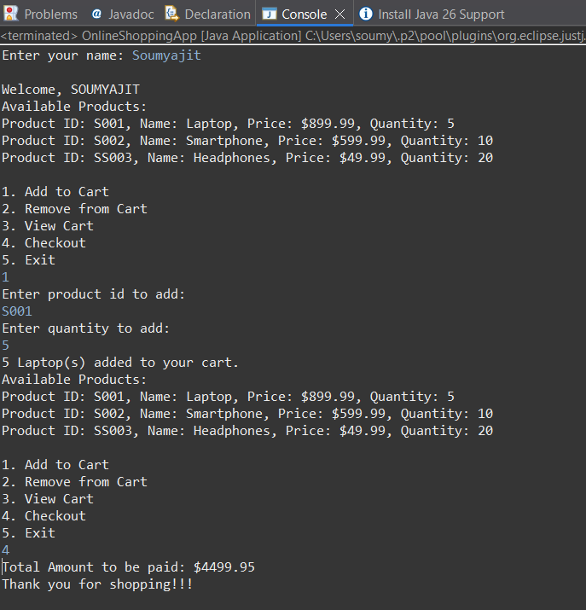
10. Conclusion
This project successfully develops a simple E-Commerce Shopping Cart Management System using Java. It allows users to easily add, update, and remove items, and calculate the total cost. The project clearly demonstrates the use of object-oriented programming concepts such as classes, inheritance, polymorphism, and exception handling.
Overall, the system is efficient, easy to understand, and can be further improved by adding advanced features like a graphical interface and database support.

PCCCS495 – Term II | E-Commerce Shopping Cart Management System | [SOUMYAJIT GHOSH] | 2026

